**Change bgcolor**

<html> 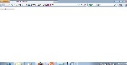

<title>changebgcolor</title> 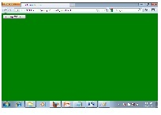

<head>

<script language="JavaScript">

function changeBGC(color){

oldcolor=window.document.bgcolor;

window.document.bgColor = "green";

window.document.alert("The Old Color Was "+ oldcolor);

}

</script>

</head>

<body>

<input type="button" onmouseover="changeBGC()" value="changeBGcolor" />

</body>

</html>

**date modified**

<html>

<title>Data modified</title>

<head>

<script language="javascript"> 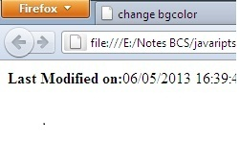

{

document.write("<b>Last Modified on:</b>"+ document.lastModified);

}

</script>

</head>

</html>

**fontcolor**

<html>

<head>

<script language="JavaScript">

function changefg(color){

document.fgColor = "green";

} C:\Users\Asif Ali Johari\Pictures\fgcolor.jpg

</script>

</head>

<font><b>Sir Jawad Usman</B></font>

<body>

<input type="button" onmouseover="changefgC()" value="changefgcolor" />

</body>

</html>

**linkcolor**

<html>

<head>

<title></title>

<meta http-equiv="Content-Type" content="text/html; charset=iso-8859-1">

<script type="text/javascript">

window.onload=function(){

document.getElementById('foo').onclick=function(){

document.getElementById('i').firstChild.style.color='red';

return false;

}

}

</script>

</head>

<body>

<a href="#">click this link<id="foo"></a></li>

<a href="asifjohari2013@gmail.com">Asif johari< id="i"></a></li>

</body>

</html>

**link**

<html>

<head>

<script type="text/javascript">

window.onload = function() {

var a = document.getElementById("mylink");

a.onclick = function() {

return false;

} 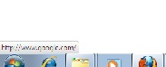

}

</script>

</head>

<body>

<a id="mylink" href="http://www.gmail.com">link</a>

</body>

</html>

**URL**

<html>

<head>

<script type="text/javascript">

function doSomething() {

alert(' you clicked on the link' );

return true; 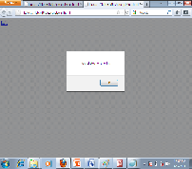

}

</script>

</head>

<body>

<b><a href="path/to/some/url" onclick="return !doSomething();">link</a></B>

</body>

</html>